Finite-state machine
rom Wikipedia, the free encyclopedia
(Redirected from Finite state machine)
Jump to: navigation, search
"State machine" redirects here. For infinite state machines, see State transition system.
"SFSM" redirects here. For the Italian railway company, see Circumvesuviana.
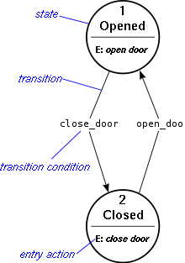
Fig. 1 Example of a simple finite state machine
A finite-state machine (FSM) or finite-state automaton (plural: automata), or simply a state machine, is a mathematical abstraction sometimes used to design digital logic or computer programs. It is a behavior model composed of a finite number of states, transitions between those states, and actions, similar to a flow graph in which one can inspect the way logic runs when certain conditions are met. It has finite internal memory, an input feature that reads symbols in a sequence, one at a time without going backward; and an output feature, which may be in the form of a user interface, once the model is implemented. The operation of an FSM begins from one of the states (called a start state), goes through transitions depending on input to different states and can end in any of those available, however only a certain set of states mark a successful flow of operation (called accept states).
Finite-state machines can solve a large number of problems, among which are electronic design automation, communication protocol design, parsing and other engineering applications. In biology and artificial intelligence research, state machines or hierarchies of state machines are sometimes used to describe neurological systems and in linguistics—to describe the grammars of natural languages.

Contents
[hide]
- 1 Concepts and vocabulary
- 2 Classification
  - 2.1 Acceptors and recognizers
    - 2.1.1 Start state
    - 2.1.2 Accept state
  - 2.2 Transducers
  - 2.3 Determinism
- 3 UML state machines
- 4 Alternative semantics
- 5 FSM logic
- 6 Mathematical model
- 7 Optimization
- 8 Implementation
  - 8.1 Hardware applications
  - 8.2 Software applications
- 9 See also
- 10 Further reading
  - 10.1 General
  - 10.2 Finite state machines (automata theory) in theoretical computer science
  - 10.3 Abstract state machines in theoretical computer science
  - 10.4 Machine learning using finite-state algorithms
  - 10.5 Hardware engineering: state minimization and synthesis of sequential circuits
  - 10.6 Finite Markov chain processes
- 11 References
- 12 External links

[edit] Concepts and vocabulary
A current state is determined by past states of the system. As such, it can be said to record information about the past, i.e., it reflects the input changes from the system start to the present moment. The number and names of the states typically depend on the different possible states of the memory, e.g. if the memory is three bits long, there are 8 possible states. A transition indicates a state change and is described by a condition that would need to be fulfilled to enable the transition. An action is a description of an activity that is to be performed at a given moment. There are several action types:
Entry action
which is performed when entering the state
Exit action
which is performed when exiting the state
Input action
which is performed depending on present state and input conditions
Transition action
which is performed when performing a certain transition
An FSM can be represented using a state diagram (or state transition diagram) as in figure 1 above. Besides this, several state transition table types are used. The most common representation is shown below: the combination of current state (e.g. B) and input (e.g. Y) shows the next state (e.g. C). The complete actions information can be added only using footnotes. An FSM definition including the full actions information is possible using state tables (see also VFSM).
State transition table
Current state →  Input ↓ | State A | State B | State C
Input X | ... | ... | ...
Input Y | ... | State C | ...
Input Z | ... | ... | ...
In addition to their use in modeling reactive systems presented here, finite state automata are significant in many different areas, including electrical engineering, linguistics, computer science, philosophy, biology, mathematics, and logic. Finite state machines are a class of automata studied in automata theory and the theory of computation. In computer science, finite state machines are widely used in modeling of application behavior, design of hardware digital systems, software engineering, compilers, network protocols, and the study of computation and languages.

[edit] Classification
There are two different groups of state machines: Acceptors/Recognizers and Transducers.

[edit] Acceptors and recognizers
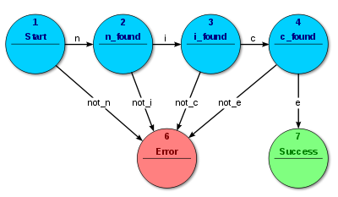
Fig. 2 Acceptor FSM: parsing the word "nice"
Acceptors and recognizers (also sequence detectors) produce a binary output, saying either yes or no to answer whether the input is accepted by the machine or not. All states of the FSM are said to be either accepting or not accepting. At the time when all input is processed, if the current state is an accepting state, the input is accepted; otherwise it is rejected. As a rule the input are symbols (characters); actions are not used. The example in figure 2 shows a finite state machine which accepts the word "nice". In this FSM the only accepting state is number 7.
The machine can also be described as defining a language, which would contain every word accepted by the machine but none of the rejected ones; we say then that the language is accepted by the machine. By definition, the languages accepted by FSMs are the regular languages—that is, a language is regular if there is some FSM that accepts it.

[edit] Start state
The start state is usually shown drawn with an arrow "pointing at it from any where" (Sipser (2006) p. 34).

[edit] Accept state
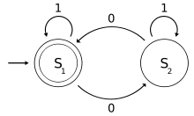
Fig. 3: A finite state machine that determines if a binary number has an odd or even number of 0s where S₁ is an accepting state.
An accept state (sometimes referred to as an accepting state) is a state at which the machine has successfully performed its procedure. It is usually represented by a double circle.
An example of an accepting state appears on the right in this diagram of a deterministic finite automaton (DFA) which determines if the binary input contains an even number of 0s.
S₁ (which is also the start state) indicates the state at which an even number of 0s has been input and is therefore defined as an accepting state. This machine will give a correct end state if the binary number contains an even number of zeros including a string with no zeros. Examples of strings accepted by this DFA are epsilon (the empty string), 1, 11, 11..., 00, 010, 1010, 10110 and so on.

[edit] Transducers
Transducers generate output based on a given input and/or a state using actions. They are used for control applications and in the field of computational linguistics. Here two types are distinguished:
Moore machine
The FSM uses only entry actions, i.e., output depends only on the state. The advantage of the Moore model is a simplification of the behaviour. Consider an elevator door. The state machine recognizes two commands: "command_open" and "command_close" which trigger state changes. The entry action (E:) in state "Opening" starts a motor opening the door, the entry action in state "Closing" starts a motor in the other direction closing the door. States "Opened" and "Closed" stop the motor when fully opened or closed. They signal to the outside world (e.g., to other state machines) the situation: "door is open" or "door is closed".
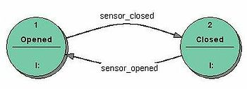
Fig. 4 Transducer FSM: Mealy model example
Mealy machine
The FSM uses only input actions, i.e., output depends on input and state. The use of a Mealy FSM leads often to a reduction of the number of states. The example in figure 4 shows a Mealy FSM implementing the same behaviour as in the Moore example (the behaviour depends on the implemented FSM execution model and will work, e.g., for virtual FSM but not for event driven FSM). There are two input actions (I:): "start motor to close the door if command_close arrives" and "start motor in the other direction to open the door if command_open arrives". The "opening" and "closing" intermediate states are not shown.
In practice mixed models are often used.
More details about the differences and usage of Moore and Mealy models, including an executable example, can be found in the external technical note "Moore or Mealy model?"

[edit] Determinism
A further distinction is between deterministic (DFA) and non-deterministic (NDFA, GNFA) automata. In deterministic automata, every state has exactly one transition for each possible input. In non-deterministic automata, an input can lead to one, more than one or no transition for a given state. This distinction is relevant in practice, but not in theory, as there exists an algorithm which can transform any NDFA into a more complex DFA with identical functionality.
The FSM with only one state is called a combinatorial FSM and uses only input actions. This concept is useful in cases where a number of FSM are required to work together, and where it is convenient to consider a purely combinatorial part as a form of FSM to suit the design tools.

[edit] UML state machines
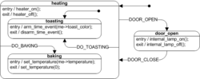
Fig. 5 UML state machine example (a toaster oven)
Main article: UML state machine
The Unified Modeling Language has a very rich semantics and notation for describing state machines. UML state machines overcome the limitations of traditional finite state machines while retaining their main benefits. UML state machines introduce the new concepts of hierarchically nested states and orthogonal regions, while extending the notion of actions. UML state machines have the characteristics of both Mealy machines and Moore machines. They support actions that depend on both the state of the system and the triggering event, as in Mealy machines, as well as entry and exit actions, which are associated with states rather than transitions, as in Moore machines.

[edit] Alternative semantics
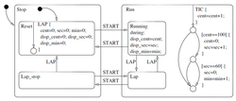
Fig. 6 Model of a simple stopwatch^{[1]}
There are other sets of semantics available to represent state machines. For example, there are tools for modeling and designing logic for embedded controllers^{[2]}. They combine hierarchical state machines, flow graphs, and truth tables into one language, resulting in a different formalism and set of semantics^{[3]}. Figure 6 illustrates this mix of state machines and flow graphs with a set of states to represent the state of a stopwatch and a flow graph to control the ticks of the watch. These charts, like Harel's original state machines^{[4]}, support hierarchically nested states, orthogonal regions, state actions, and transition actions^{[5]}.

[edit] FSM logic
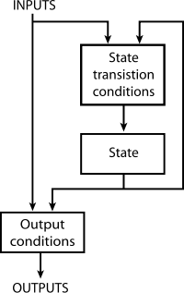
Fig. 7 FSM Logic (Mealy)
The next state and output of an FSM is a function of the input and of the current state. The FSM logic is shown in Figure 7.

[edit] Mathematical model
In accordance to the general classification, the following formal definitions are found:
- A deterministic finite state machine or acceptor deterministic finite state machine is a quintuple (Σ,S,s₀,δ,F), where:
  - Σ is the input alphabet (a finite, non-empty set of symbols).
  - S is a finite, non-empty set of states.
  - s₀ is an initial state, an element of S.
  - δ is the state-transition function: (in a nondeterministic finite state machine it would be , i.e., δ would return a set of states).
  - F is the set of final states, a (possibly empty) subset of S.
For both deterministic and non-deterministic FSMs, it is conventional to allow δ to be a partial function, i.e. δ(q,x) does not have to be defined for every combination of and . If an FSM M is in a state q, the next symbol is x and δ(q,x) is not defined, then M can announce an error (i.e. reject the input).
- A finite state transducer is a sextuple (Σ,Γ,S,s₀,δ,ω), where:
  - Σ is the input alphabet (a finite non empty set of symbols).
  - Γ is the output alphabet (a finite, non-empty set of symbols).
  - S is a finite, non-empty set of states.
  - s₀ is the initial state, an element of S. In a Nondeterministic finite state machine, s₀ is a set of initial states.
  - δ is the state-transition function: .
  - ω is the output function.
If the output function is a function of a state and input alphabet () that definition corresponds to the Mealy model, and can be modelled as a Mealy machine. If the output function depends only on a state () that definition corresponds to the Moore model, and can be modelled as a Moore machine. A finite-state machine with no output function at all is known as a semiautomaton or transition system.

[edit] Optimization
Main article: DFA minimization
Optimizing a FSM means finding the machine with the minimum number of states that performs the same function. The fastest known algorithm doing this is the Hopcroft minimization algorithm.^{[6][7]} Other techniques include using an Implication table, or the Moore reduction procedure. Additionally, acyclic FSAs can be optimized using a simple bottom up algorithm.^{[citation needed]}

[edit] Implementation

[edit] Hardware applications
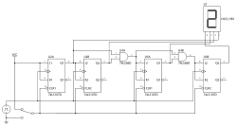
Fig. 8 The circuit diagram for a 4-bit TTL counter, a type of state machine
In a digital circuit, an FSM may be built using a programmable logic device, a programmable logic controller, logic gates and flip flops or relays. More specifically, a hardware implementation requires a register to store state variables, a block of combinational logic which determines the state transition, and a second block of combinational logic that determines the output of an FSM. One of the classic hardware implementations is the Richards controller.
Mealy and Moore machines produce logic with asynchronous output, because there is a propagation delay between the flip-flop and output. This causes slower operating frequencies in FSM. A Mealy or Moore machine can be convertible to a FSM which output is directly from a flip-flop, which makes the FSM run at higher frequencies. This kind of FSM is sometimes called Medvedev FSM.^{[8]} A counter is the simplest form of this kind of FSM.

[edit] Software applications
The following concepts are commonly used to build software applications with finite state machines:
- Automata-based programming
- Event driven FSM
- Virtual FSM (VFSM)

